API documentation and Unit test cases

for

Virta Project Document

V1.0

Author: Likhitha Pentakota

**Scope:**

**Solution:**

Solution is designed based on requirements and few assumptions.

The EV charging management system project(Assignment) has been implemented using React as a frontend and MYSQL as a backend. MySQL database has been hosted in AWS RDS cloud service. Features include List, create, update, and delete companies, stations and station types. Companies maintain hierarchy of sub companies, companies and companies have stations and station type data.

This document described the solution with all necessary configurations and user interfaces.

**Architecture:**

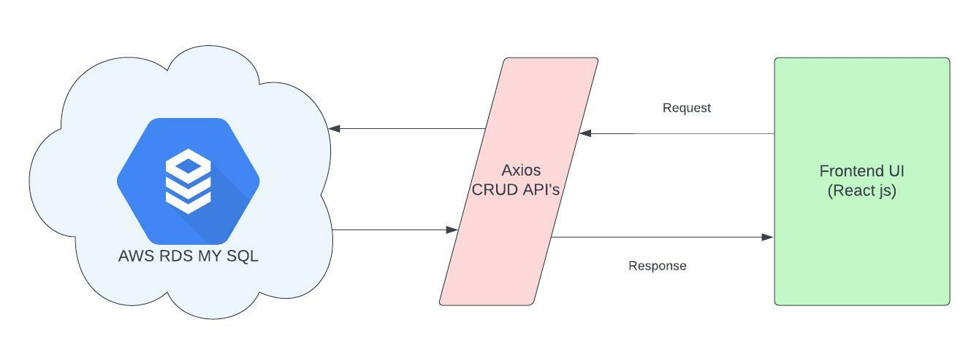

**SQL Schema’s:**

As part of the solution AWS RDS free tier with MYSQL is used to maintain schema and store the data. Since other databases are having network or connection issues, I considered AWS RDS for this solution.

Below schemas are used for this solution

|  |  |  |  |
| --- | --- | --- | --- |
| **S.No** | **Table Name** | **Table** | **Fields** |
| **1** | **Company** | **K001** | **ID - Company ID (Primary key)**  **Parent_ID - Parent company ID**  **Name - Company name** |
| **2** | **Stations** | **S001** | **SID - Station ID (Primary key)**  **CID - Company ID (Foreign key)**  **Name - Station Name** |
| **3** | **Station types** | **ST001** | **STID - Station type ID (Primary key)**  **SID - Station ID (Foreign key)**  **Name - Station type Name**  **MPower - Max. Power** |
| **4** | **History with status** | **ST001H** | **SID- Station ID**  **STID - Station types**  **MPOWER - Max. Power**  **STATUS - Station status**  **STIME - Start time**  **ETIME - End time**  **DIFF_TIME - Total time of Charge** |

**Short description:**

**User Interface:**

Below is the home page of the EV charging management system.

Initial home page screen

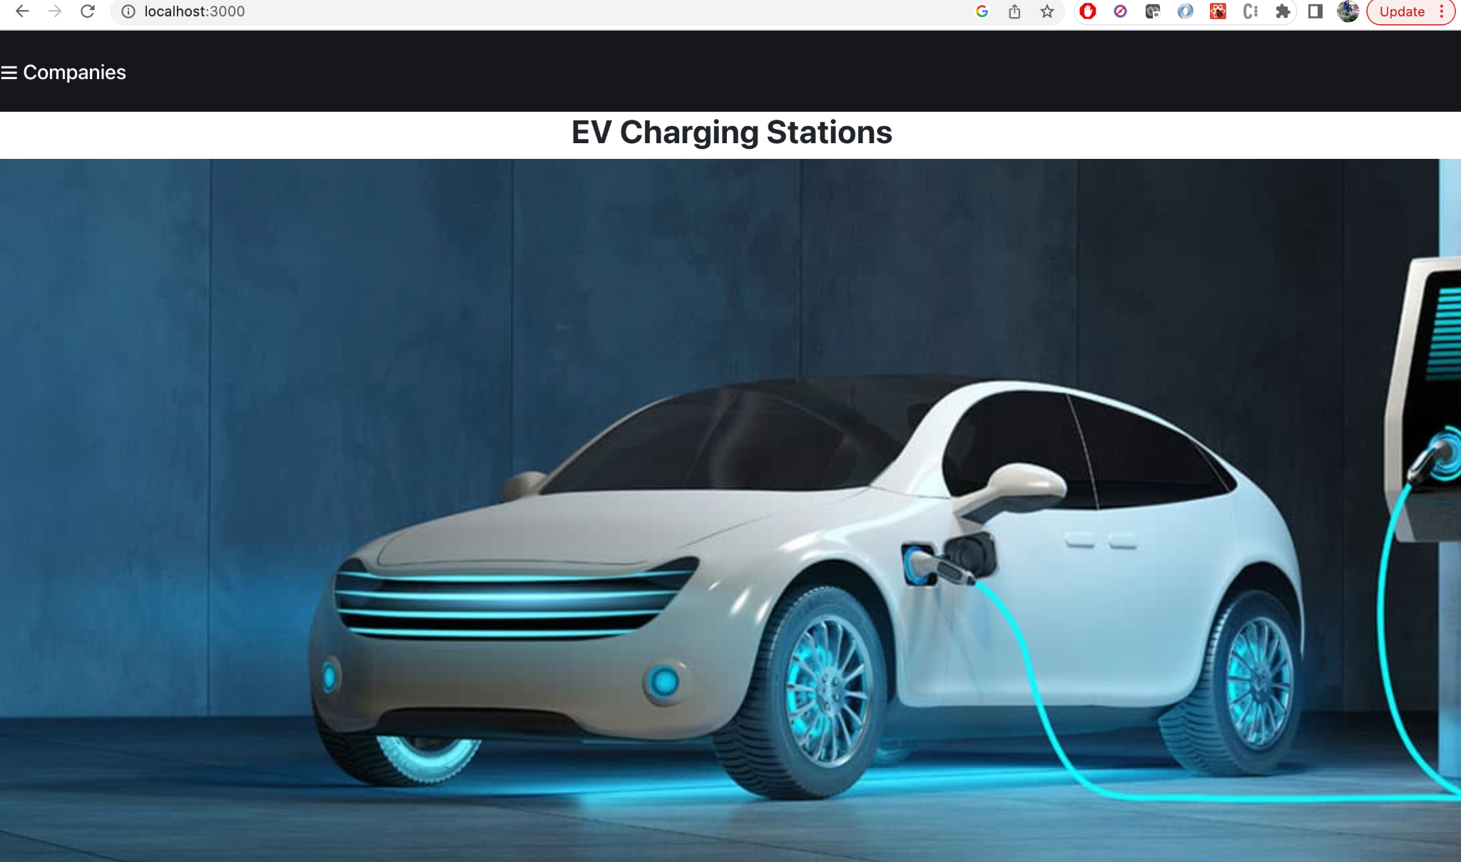

Companies are listed in left side as menu items. when the user clicks on , a list of companies(both parent and child companies) is listed with CRUD(Create, Search, Update and Delete) options as shown below.

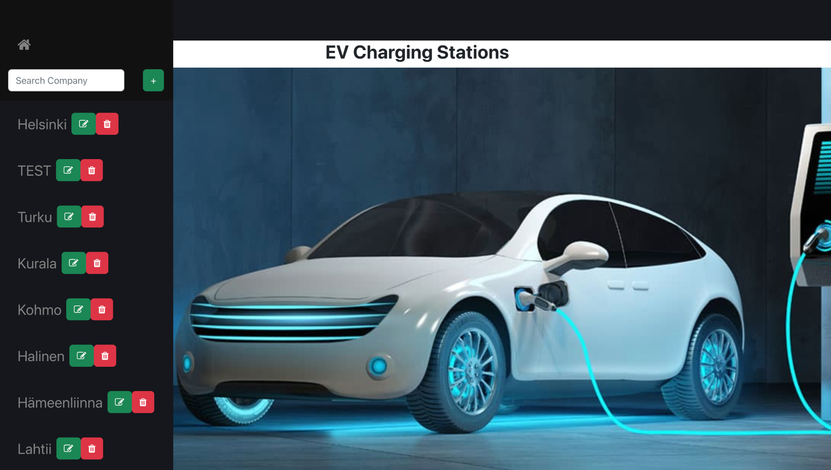

Features in company list:

**Search**: Search functionality helps to user to check any company with string operation by entering text in search input. 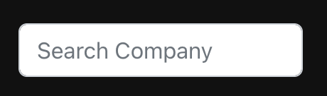.

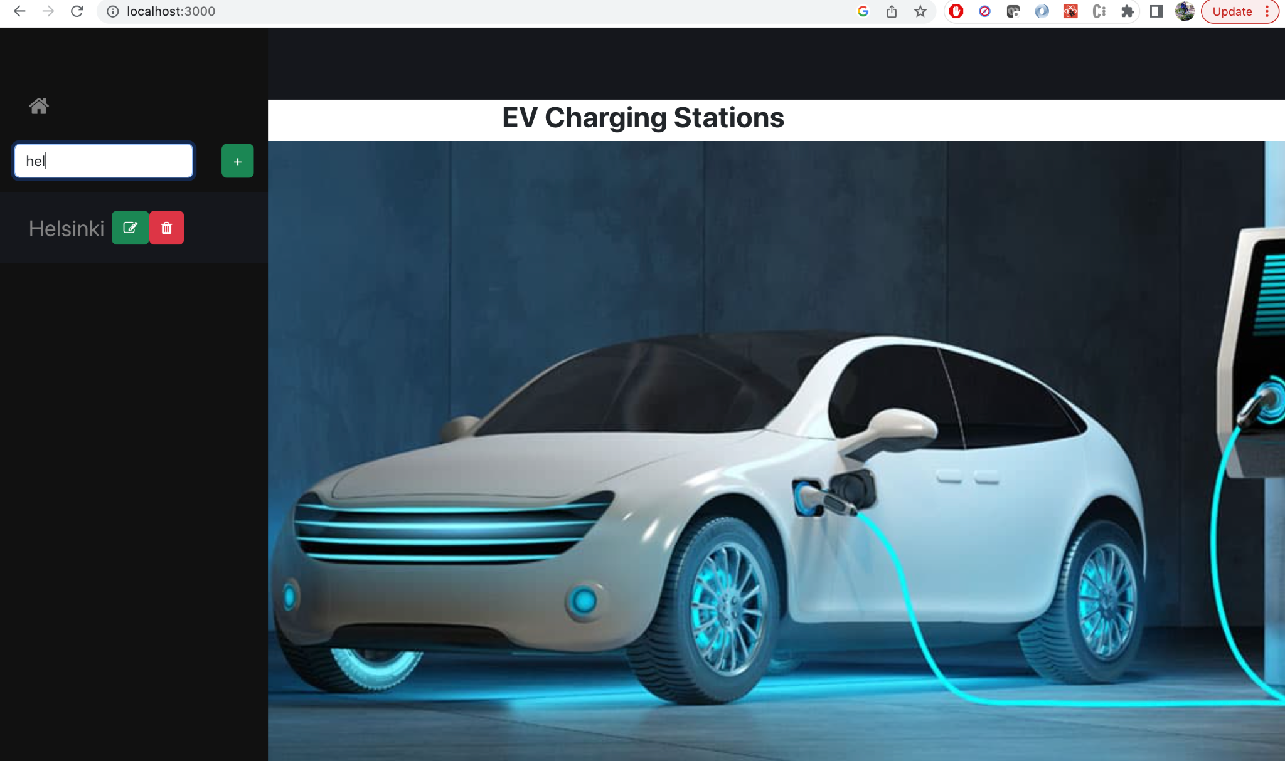

**Create**: User can create new company either parent or child company by clicking button next to search 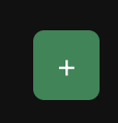

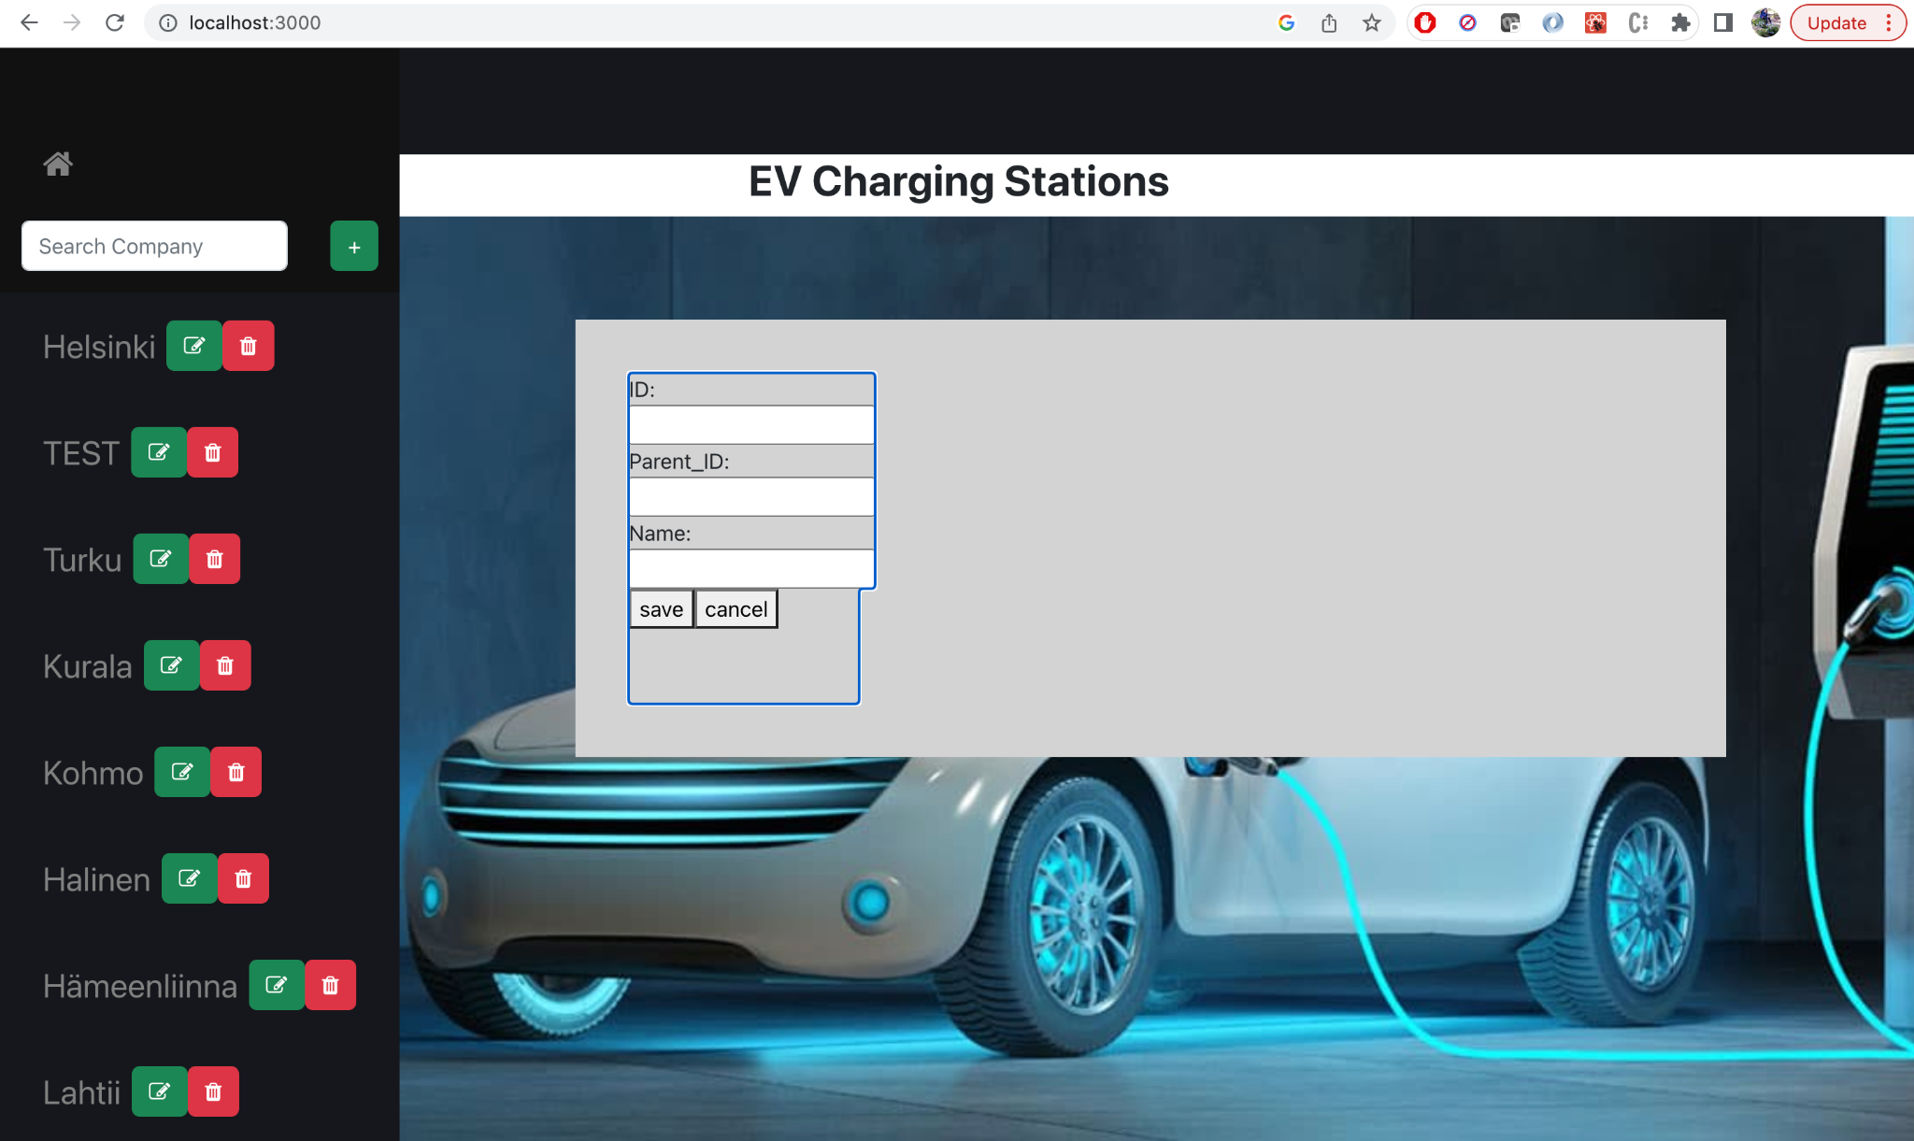

**Edit and Delete**: Company data can be edited or deleted by clicking buttons 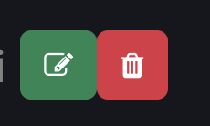 respectively.

Back to home Page: When user want to close companies and go to home page, user can click button  to go to home page.

Edit

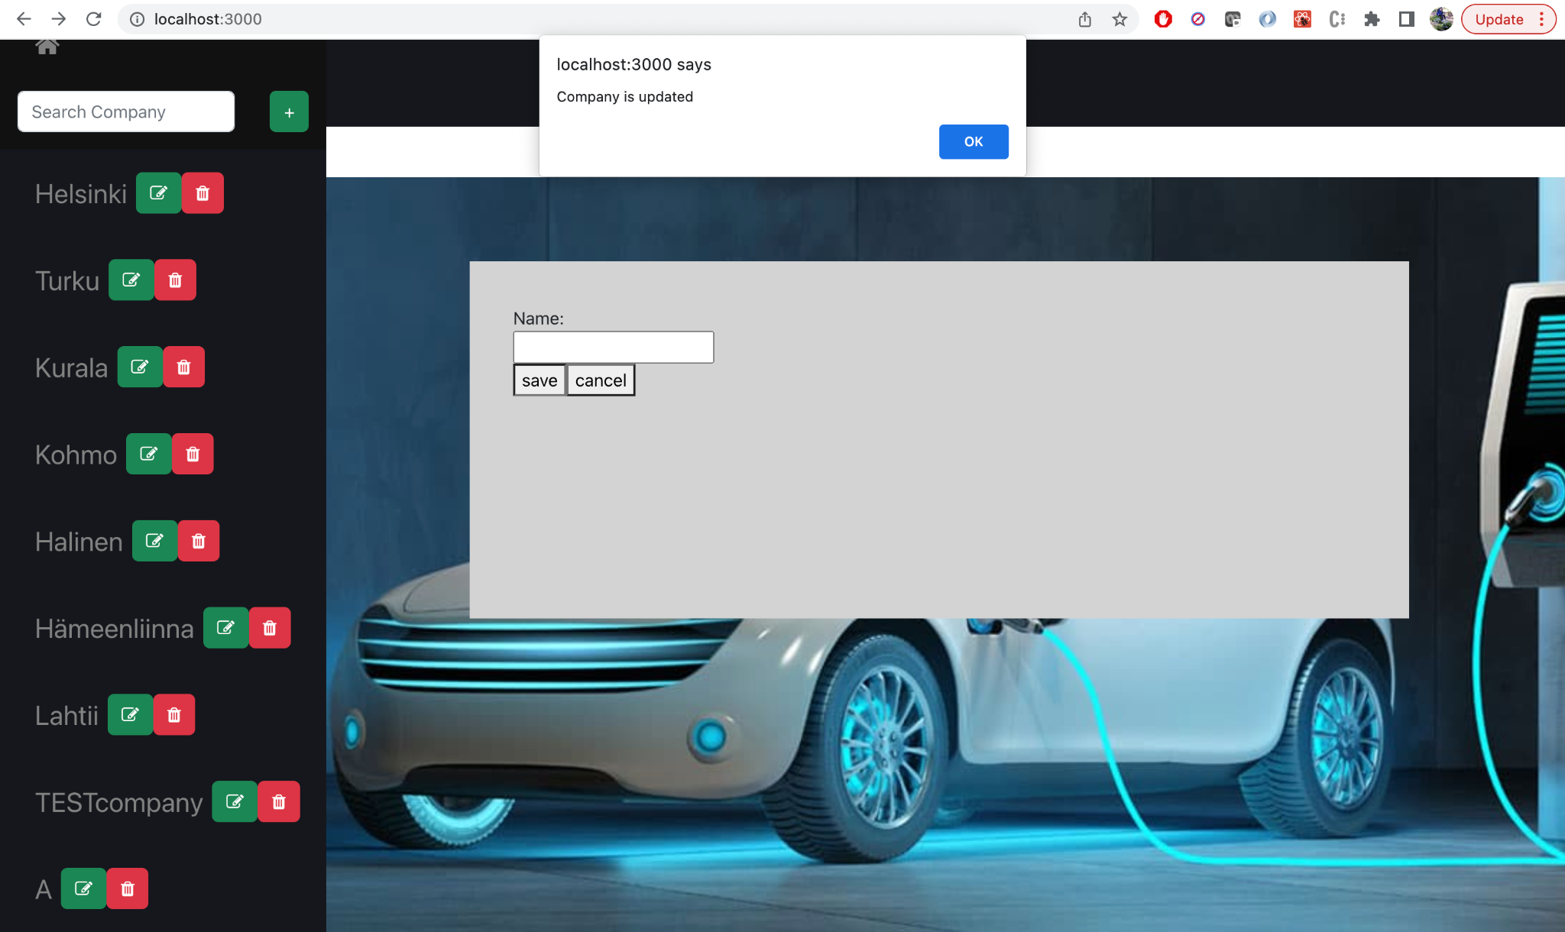

Delete

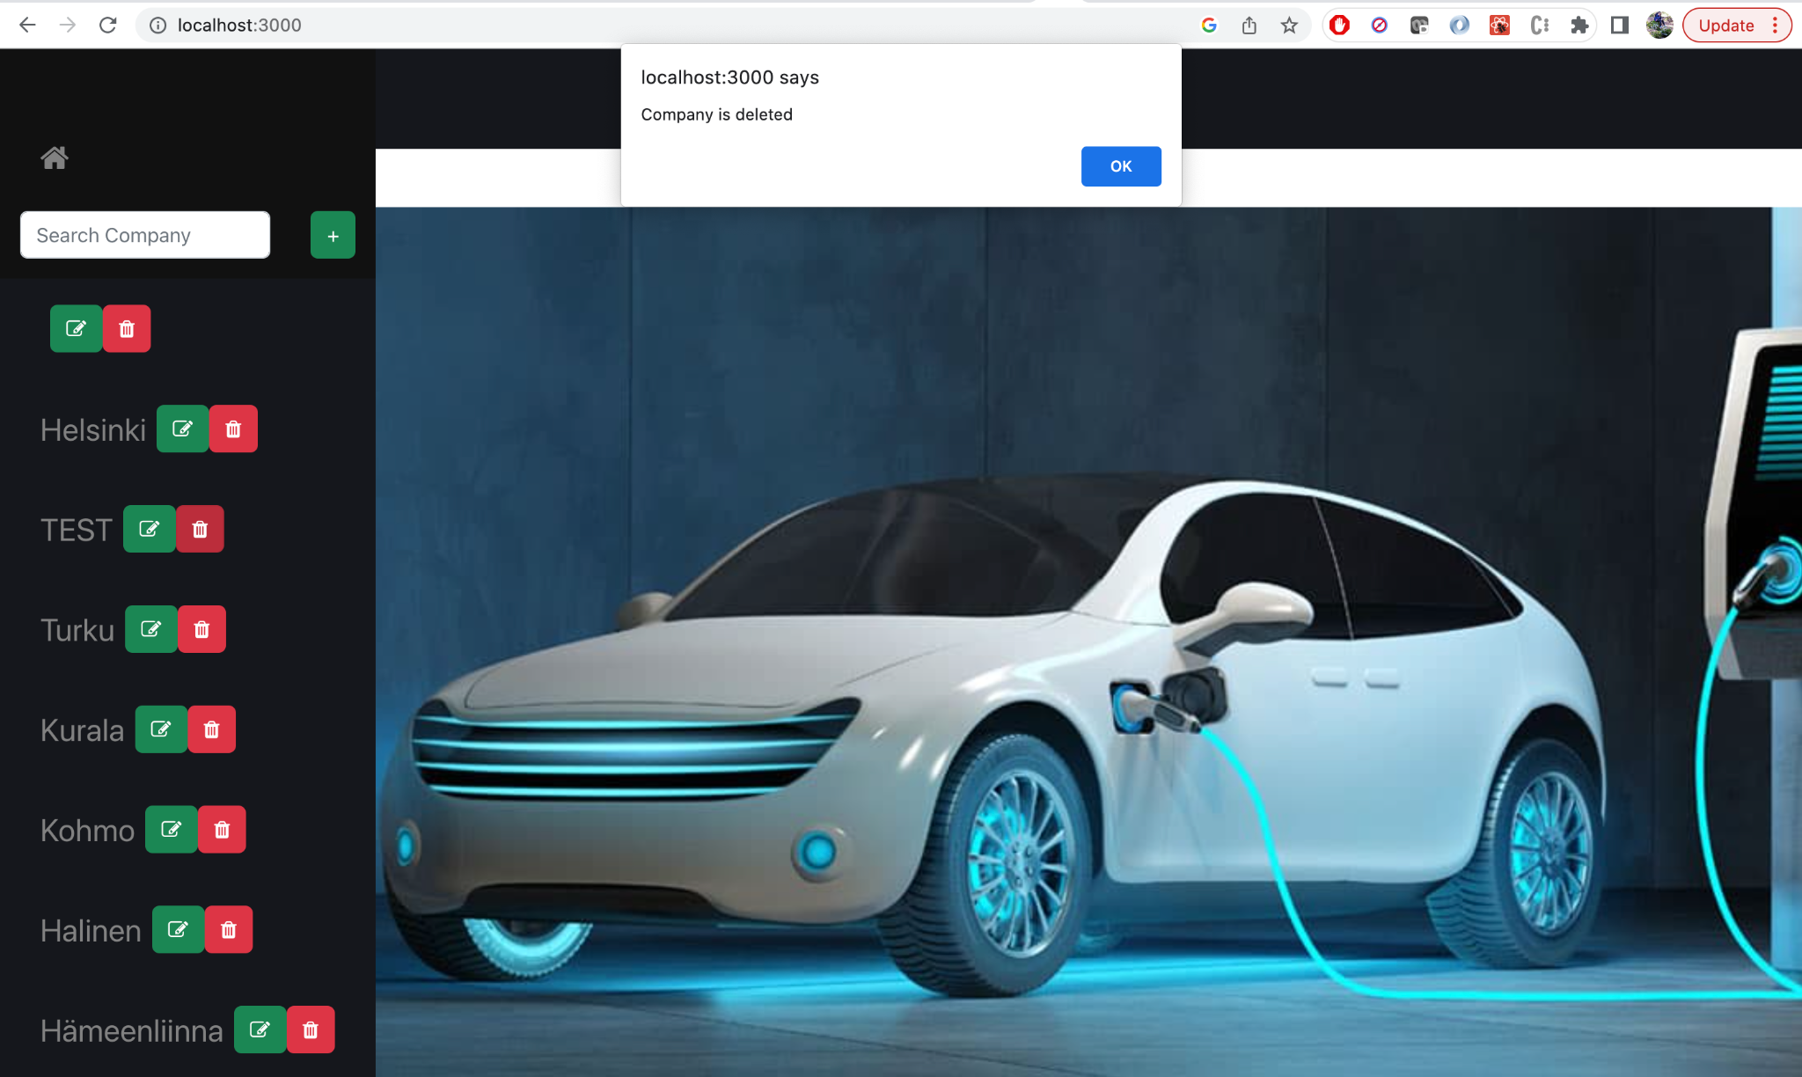

Stations:

When user click on company name it will display the stations within that company and company name displayed on the screen along with stations.

If user click on parent company, screen shows only parent company and corresponding stations.

If user click on sub company, screen shows both parent company, sub company and corresponding stations.

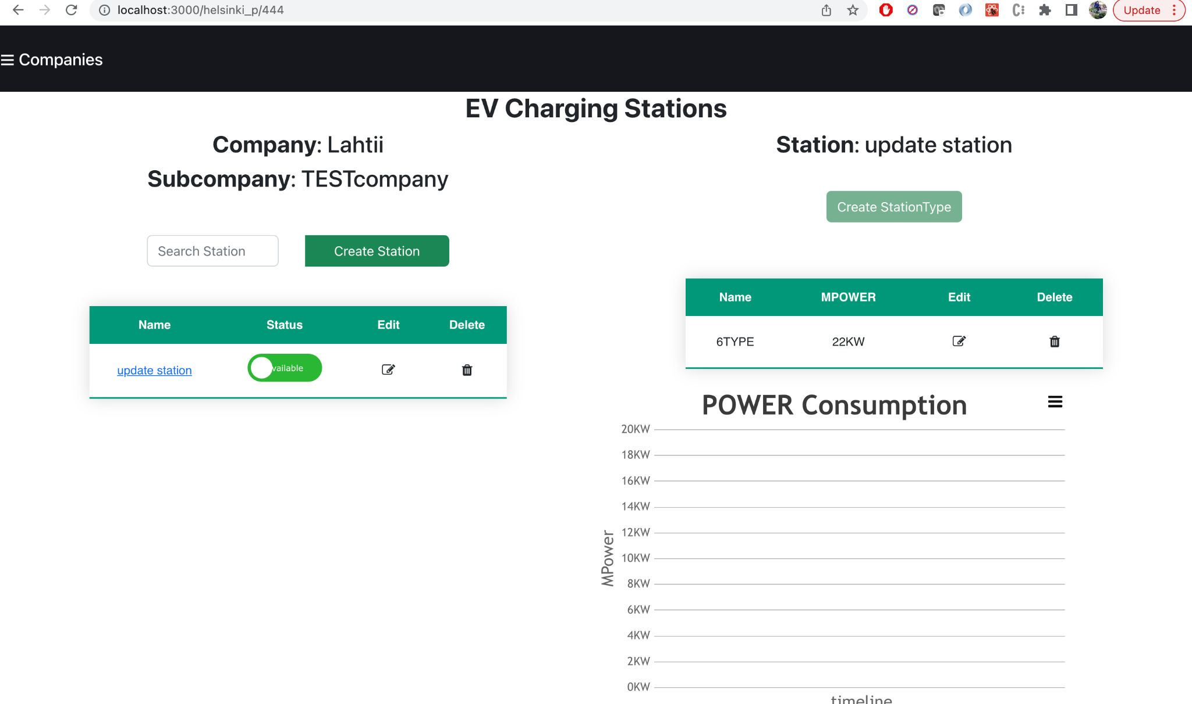

There is a search filter and crud operations for stations section. When user enter station name or any string, it shows only those matching stations based on company ID.

Search in Station list

User can use search filter to search the particular station from the displayed list.

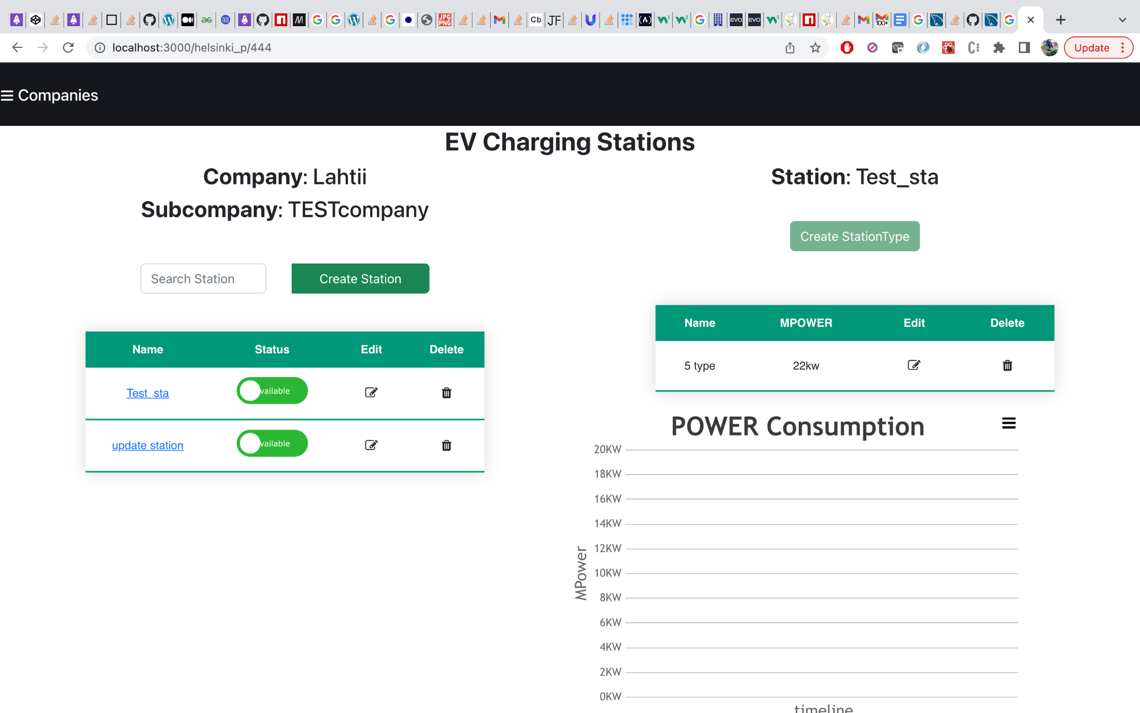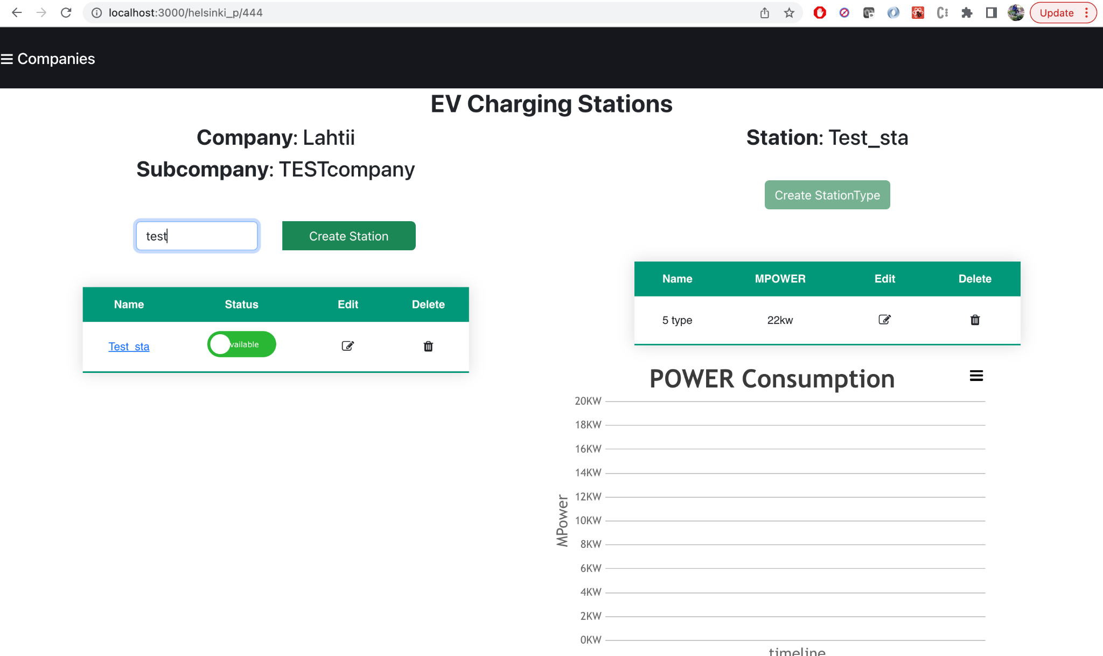

Edit and Delete:

User can edit the station data to change station name and company ID in case of station ID is mapped ith wrong company.

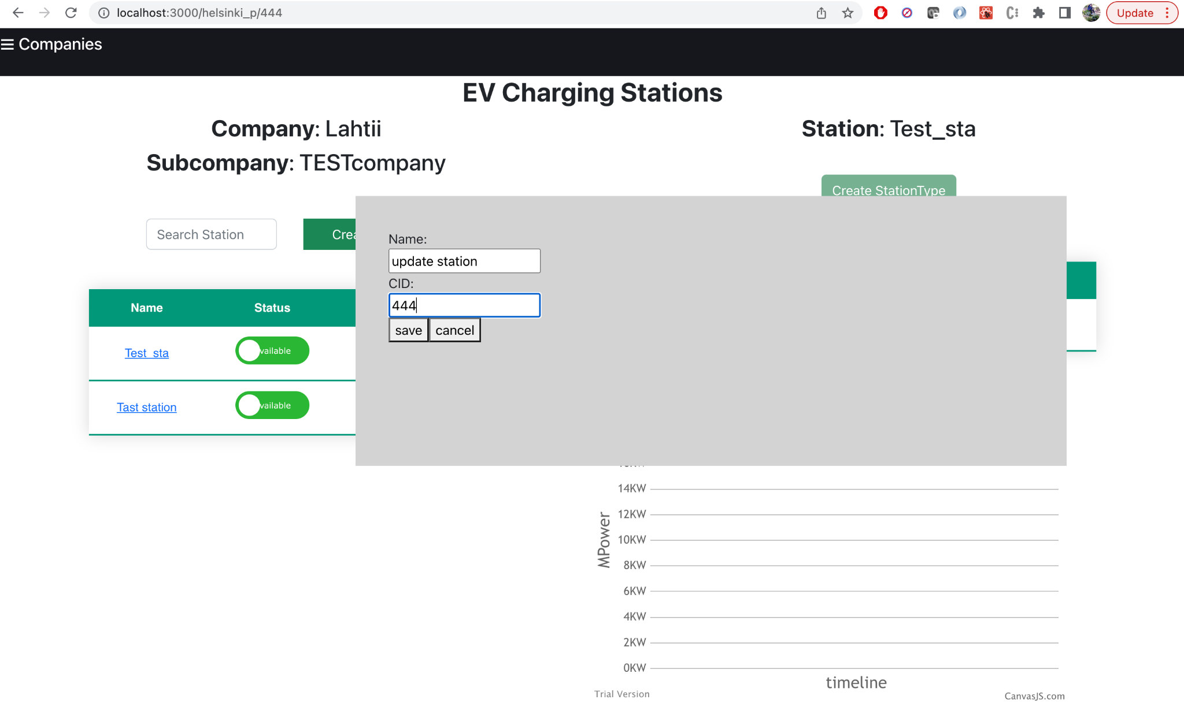

User can delete statins within a company, and it will delete all stations and station types belongs to deleting stations.

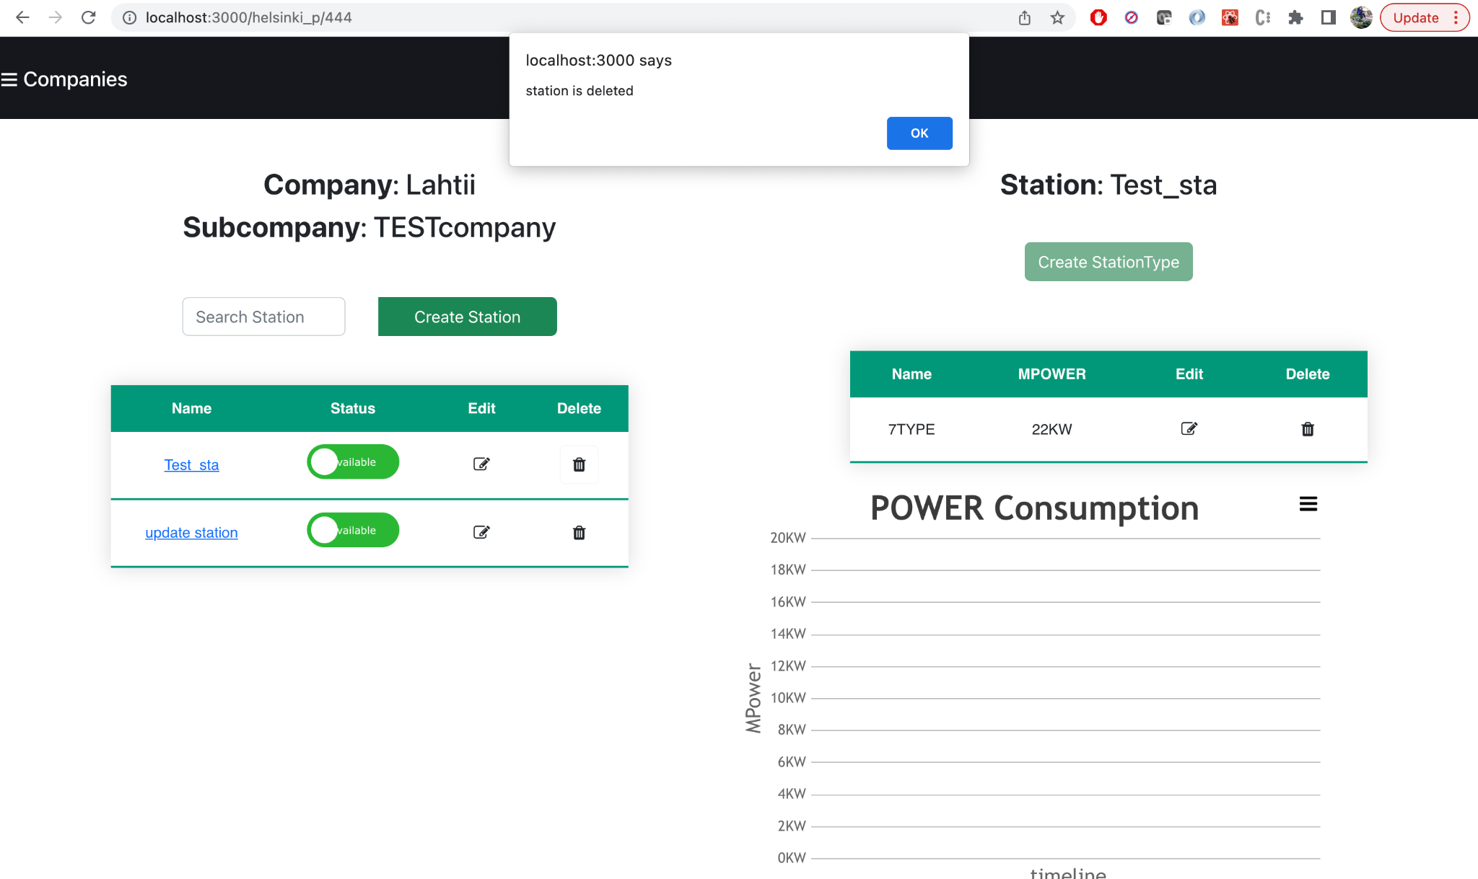

Create station:

User can click on crate stations button to create new stations in a company.

Create station button will open a popup to create a new station with SID, CID and Name. Here SID represents station id and CID represents company id Stations data is maintained in a separate entity where company id has given as link to its corresponding station. Here CID in the stations data represents the company id. In the UI stations data display based on company id. Click on Save button then it will save the data in the database.

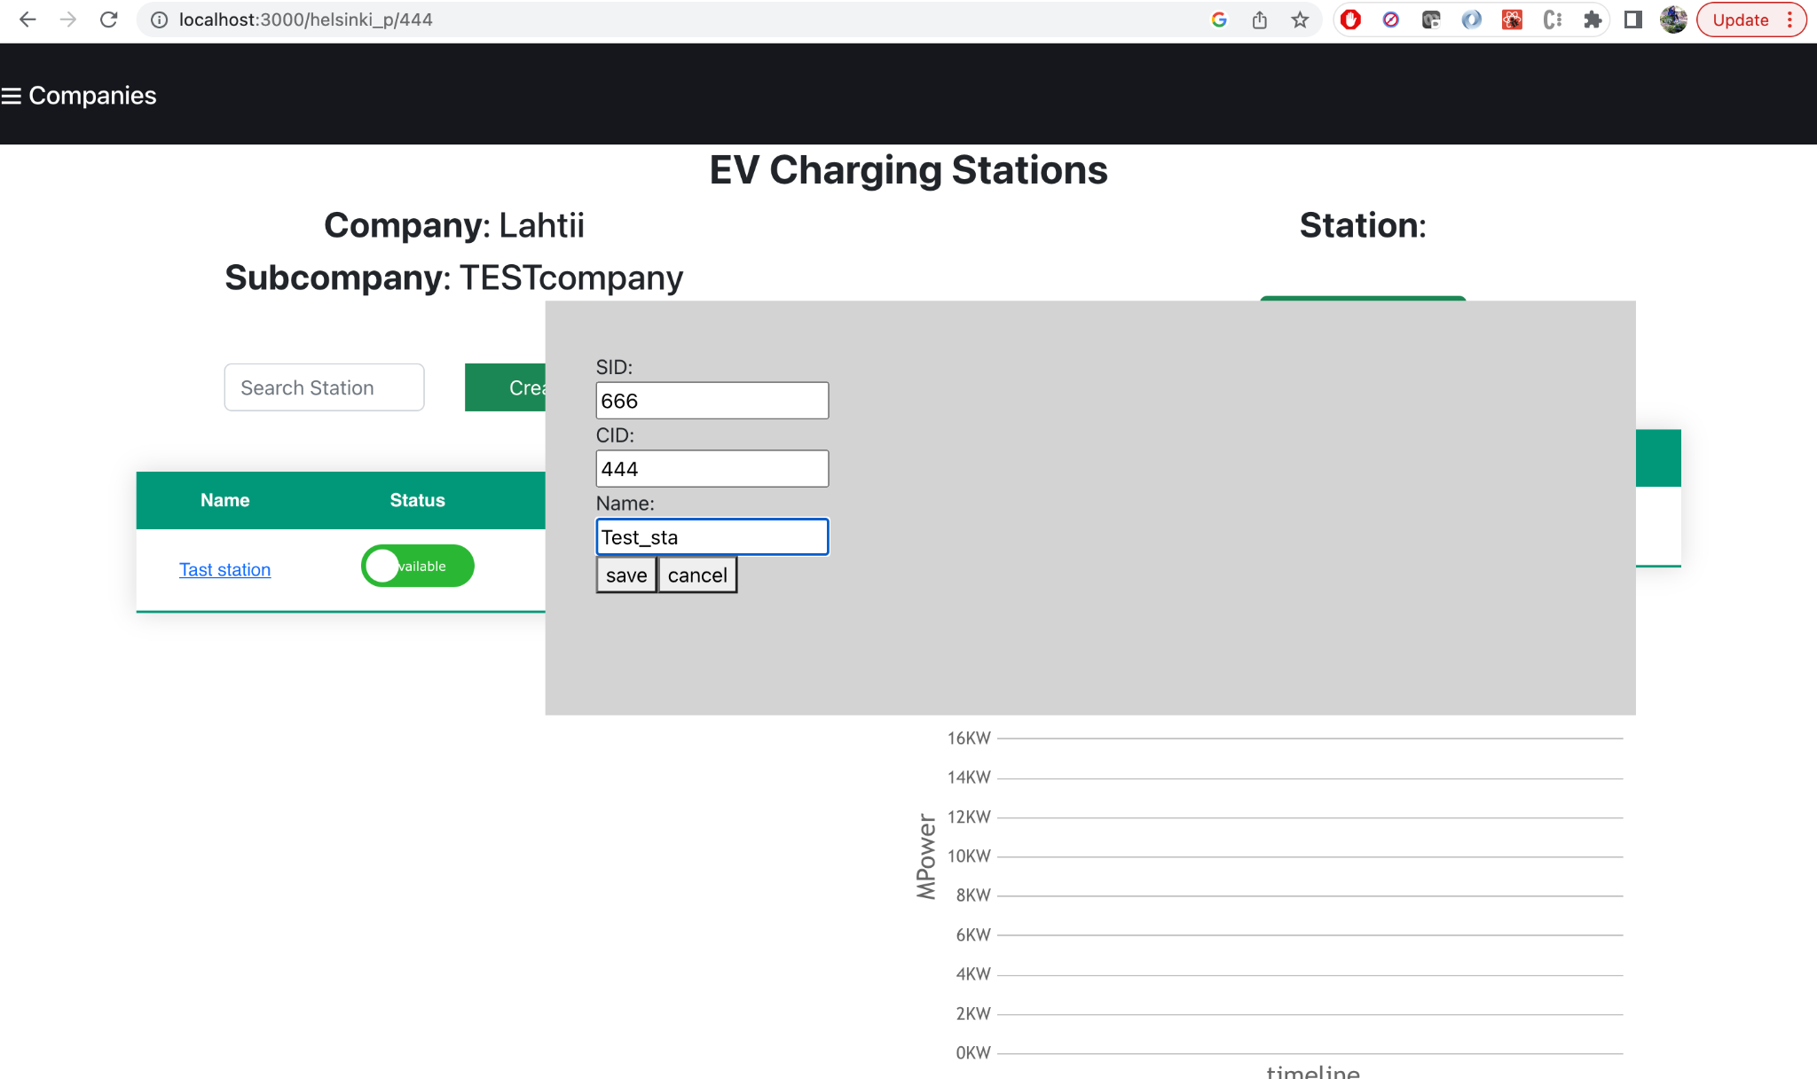

Station types:

If we click on station name it will display it’s corresponding station type data right to the station data based on SID(station id).

Adding a station type:

Since each station should have one station type the create station type button has disabled when there is station type data in that station name. To create a station type we give its respective Station id as default to its SID. first we should click on station name and click on create station type then it open a popup to create a new station with STID (station type id), NAME, MPOWER, along with its SID displayed. Click on Save button then it will save the data in the database.

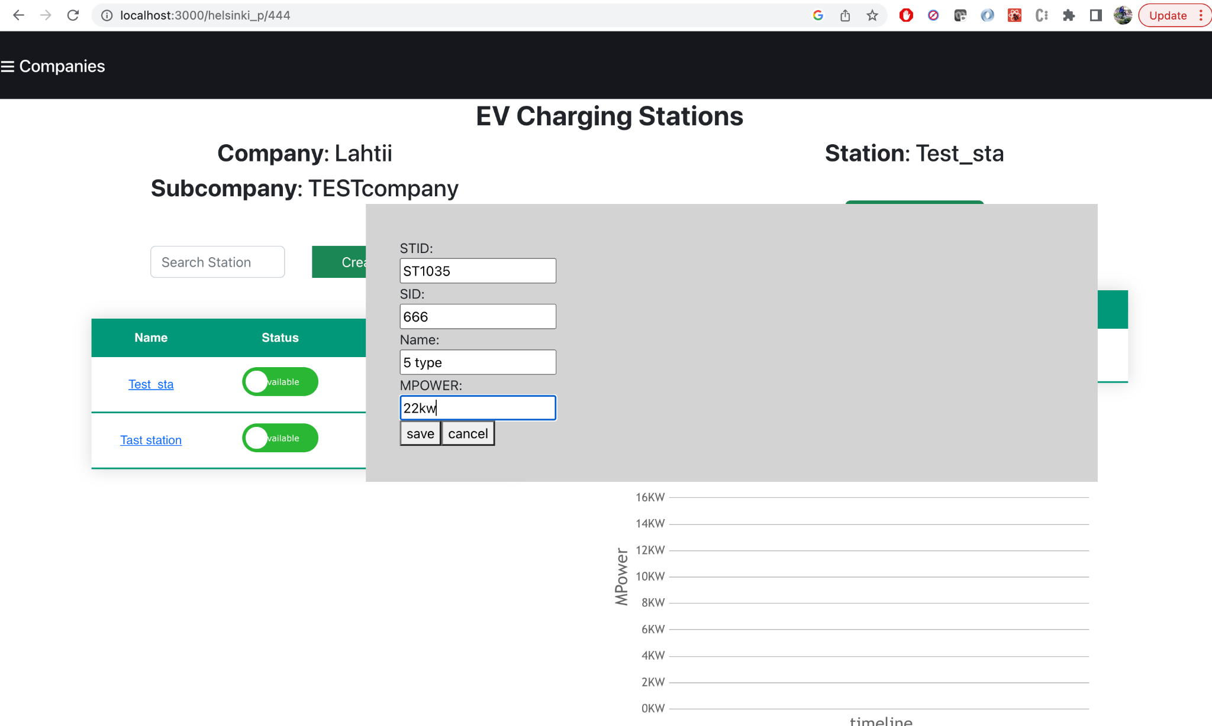

Create station type button is enabled only when there is no station type data

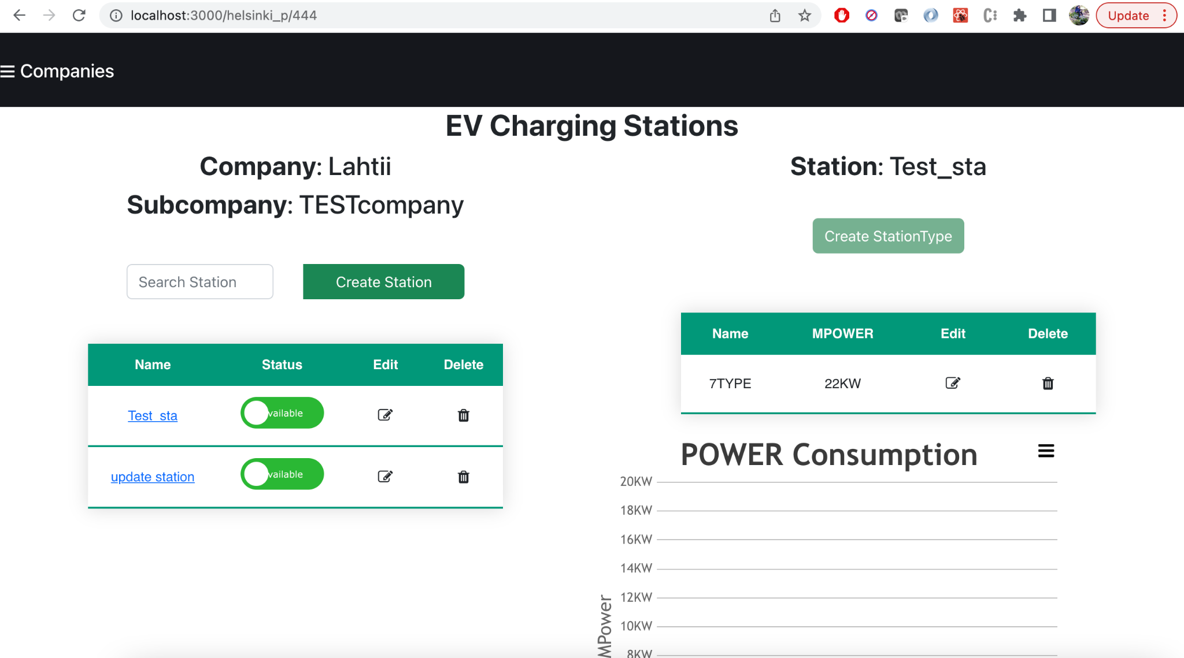

Incase station type date is available, button to create is disabled from the screen.

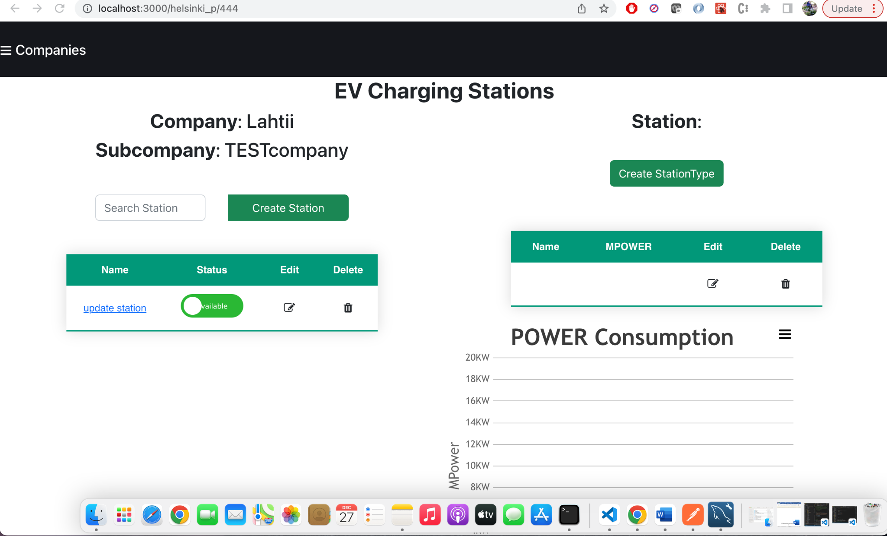

Updating a station type:

If we click on edit icon it will open the popup to update the SID(station id), NAME and MPOWER. Click on Save button then it will updates the data in the database.



Delete a station type:

If we click on delete icon it will deletes the station type.

Graph:

Graph has created to display power consumption along with time for charging periods. However, it is not fully implemented to display graph.

**EVCharging API’s**

**API References**

* **Version**: 1.0
* **Host**: localhost:3000
* **Protocols**: https
* **Accepts**: application/json
* **Responds With**: application/json
* **Backend**: MYSQL
* **Front end**: React

Cats API allows to read, write and delete cats. Collection of API for cats are described as below

1. **Get all companies (GET)**
   * Fetches all the companies in the menu list
   * Endpoint to get all companies
     1. GET **/api/company**
   * Header
     1. Content-type: application/json
   * Unit test
     1. API test with
        1. UI
2. **Get company by id (GET)**
   * Fetches the companies from the list by company id
   * Endpoint to get all cats
     1. GET **/api/company/id/:id**
   * Header
     1. Content-type: application/json
   * Unit test
     1. API test with
        1. UI

1. **Create Company (POST)**
   * Creates the new Company.
   * Endpoint to create company
     1. POST **/api/company/create**
   * Header
     1. Content-type: application/json
   * Schema

Object

Id type – int

Name type – string

parent_id type – int

* + Unit test
    1. API test with
       1. UI

1. **Update Company (PUT)**
   * Updates the existing Company by company id.
   * Endpoint to Update company
     1. PUT **/api/company/update/:id**
   * Header
     1. Content-type: application/json
   * Unit test
     1. API test with
        1. UI
2. **Delete Company (DELETE)**
   * Deletes the Company along with its stations and station types.
   * Endpoint to get all cats
     1. DELETE **/api/company/delete/:id**
   * Header
     1. Content-type: application/json
   * Unit test
     1. API test with
        1. UI

Before deletion of the record:

1. **Get stations by company id (GET)**
   * Fetches the stations in the given company id
   * Endpoint to get all cats
     1. GET **/api/station/cid/:cid**
     2. Header

Content-type: application/json

* + Unit test
    1. API test with
       1. UI

1. **Create a Station(POST)**
   * Creates a new Station
   * Endpoint to create a station
     1. POST **/api/station/create**
   * Header
     1. Content-type: application/json
   * Request body
     1. Schema

Object

sid type – varchar(45)

cid type – int

Name type – string

* + Unit test
    1. API test with
       1. UI

1. **Update Station (PUT)**
   * Updates an existing Station by station id
   * Endpoint to create a station
     1. PUT **/api/station/update/:sid**
   * Header
     1. Content-type: application/json
   * Unit test
     1. API test with
        1. UI
2. **Deletes a Station (DELETE)**
   * Deletes a station along with its station types by station id
   * Endpoint to delete a station
     1. DELETE **/api/station/delete/:sid**
   * Header
     1. Content-type: application/json
   * Unit test
     1. API test with
        1. UI
3. **Get Station types (GET)**
   * Fetches station type by given station id
   * Endpoint to get station types by station id
     1. GET **/api/stationtype/sid/:sid**
   * Header
     1. Content-type: application/json
   * Unit test
     1. API test with
        1. UI
4. **Creates a Station Type (POST)**
5. Creates a new Station type
6. Endpoint to create a station
   * 1. POST **/api/stationtype/create**

c. Header

* + 1. Content-type: application/json
  + Request body
    1. Schema

Object

STID type – varchar(45)

SID type – varchar(45)

NAME type – string

MPOWER type – string

* + Unit test
    1. API test with
       1. UI

1. **Update Station type (PUT)**
   * Updates an existing Station type by station type id
   * Endpoint to create a station type
     1. PUT **/api/station_type/update/:stid**
   * Header
     1. Content-type: application/json
   * Unit test
     1. API test with
        1. UI
2. **Deletes a Station (DELETE)**
   * Deletes a station type by station type id
   * Endpoint to delete a station type
     1. DELETE **/api/stationtype/delete/:stid**
   * Header
     1. Content-type: application/json
   * Unit test
     1. API test with
        1. UI
3. **Create station status**
   * Inserts station current information based on station current status
   * Endpoint to insert station status info
     1. POST  **/api/company/stationstatus/c**
   * Header
     1. Content-type: application/json
4. **Update station status**
   * Updates on current Station status
   * Endpoint to to update the station status
     1. POST  **/api/company/station_status/a/:sid**
   * Header
     1. Content-type: application/json
5. **Get station status**
   * Gets a current station status
   * Endpoint to to update the station status
     1. POST  **/api/company/station_status/:sid**
   * Header
     1. Content-type: application/json

Conclusion:

1. I feel, It is required more time to implement complete E2E solution with better UI and API’s effectively.
2. There are some challenges with SQL data base and then I moved to use AWS RDS with MYSQL with free tier.
3. I am not sure, but I just want to inform that I faced some temparary connection issues with proxy errors but those are fixed automatically.